**ITSM-** ITSM (or IT Service Management) refers to all the activities involved in designing, creating, delivering, supporting and managing the lifecycle of IT services.

**ITIL Vs COBIT**

**Ans.** The following are the major differences between ITIL and COBIT:

|  |  |  |
| --- | --- | --- |
| **Details** | **COBIT** | **ITIL** |
| Purpose | Integration of IT | ITSM (Information Technology Service Management) |
| Latest Version | COBIT 5 - April 2012 | **ITIL V4** - 2019 |
| Operations | To derive guidelines for organizational operations | To implement guidelines of an organization |
| Application | Process descriptions | Process implementations |
| Additional features | control objectives, management guidelines, maturity models | Service strategies, design, transitions, operation implementations |

**Q1. What is ITIL?**

**Ans.** **Information Technology Infrastructure Library** (ITIL) is a collection of comprehensive practices for IT Service Management (ITSM), which focuses on IT services alignment with the requirements of business needs.

It helps businesses to achieve their mission with the best way to plan, manage, and deliver.

**Q2. ITIL V3 framework consists of which processes?**

**Ans.** ITIL V3 organizes **ITIL processes** into five service lifecycle stages:

* Service strategy
* [**Service design**](https://mindmajix.com/itil/lifecycle-service-design)
* Service transition
* Service operation
* Continual service improvement

**Q3. Explain the benefits of ITIL.**

**Ans.** The major benefits of ITIL are listed below:

* Powerful alignment between the business and IT
* Improves customer satisfaction and service delivery
* Improved utilization of resources by lowering costs
* Comprehensive visibility of IT costs and assets
* Better administration of business risk and service disruption
* Supports constant business change for a stable service environment

**Q4. What are the benefits of implementing an ITIL service desk?**

**Ans.** The main benefits of Service Desk implementation are:

* Increased first call resolution
* Improved tracking of service quality
* Improved recognition of trends and incidents
* Improved employee satisfaction
* Skill-based support
* Rapid restoration of service
* Improved incident response time
* Quick service restoration

**Q5. What processes are utilized by the Service Desk?**

**Ans.** Workflow and procedures diagrams

**Q6. What are the objectives of Incident Management?**

**Ans.** The main objectives of the incident management process are listed below:

* Assure that regulated methods and procedures are used for the prompt and efficient response, reporting of incidents, documentation, analysis, and ongoing management
* Progress visibility and communication of incidents to IT support staff and business
* Improve the business perception of IT by resolving and reporting incidents when they occur
* Align Incident Management activities and priorities accordingly
* Manage user satisfaction with the quality of IT services

**Q7. How an Incident Management System Works?**

**Ans.**

* Records incidents
* Lists them depending on their impact and urgency
* Authorizes the incident to the relevant responding personnel
* Resolution and recovery

**Q8. What are the stages of incident management in ITIL?**

**Ans.** Incident Management is the process of managing the lifecycle of incidents that are reported. It consists of several steps that must be carried out to resolve and document the incidents.

The following are the steps of incident management process:

* **Step1:** Incident identification
* **Step2:** Incident logging
* **Step3**: Incident categorization
* **Step4:** Incident prioritization
* **Step5:** Incident response
* **Step6:** Initial diagnosis
* **Step7:** Incident escalation
* **Step8:** Resolution and recovery
* **Step9:** Incident closure

**Q9. What is an SLA?**

**Ans.** An **SLA** (Service Level Agreement) is a commitment between a service provider (internal or external) and the end-user. It represents the level of service assumed by the service provider.

**Q10. Explain different types of SLA.**

**Ans.** Service Level Agreements are defined into three types:

* A **customer service level agreement** exists between you and an external customer.
* An **internal service level agreement** exists between you and an internal customer (such as another organization, site, or department).
* A **vendor service level agreement** exists between you and the vendor.

**Q11. What is the purpose of Problem Management in ITIL?**

**Ans.**

* Identify and troubleshoot potentially recurring incidents
* Determine the root cause
* Take steps to prevent the incident from reoccurring

**Q12 What are the stages in the overall Problem Management Process?**

**Ans.**

* Detect and log the problem
* Categorize and prioritize the problem
* Investigate and diagnose
* Identify a workaround for the problem
* Raise a known error record
* Resolve the problem
* Close the problem
* Review the problem

**Q13.What is a Known Error?**

**Ans.** A Known Error is a problem that has a recorded root cause and a workaround.

Example- Memory issue, and heap size needs to increase.

A Known Error record contains the following:

* Status
* Error description
* Root cause
* Workaround

|  |
| --- |
| Problem + Root Cause + Workaround = Known Error |

**Q14. How does a known error close?**

**Ans.** Known Error closes depending on the following conditions:

* When all the Request for Change (RFC) records are closed.
* The Known Error Details section must have information about a Root Cause, Solution, and Workaround before you can close the known error record.
* When a record is in the Error Closure phase.

**Q15. What are the objectives of the IT Service Continuity Management?**

**Ans.**

* Analysing the risks.
* Testing back-out arrangements.
* Drawing up back-out scenarios.

**Q16. What is the purpose of Configuration Management in ITIL?**

**Ans.** The primary purpose of Configuration Management is to collect, store, manage, update, and verify data on IT assets and configurations in the enterprise.

**Q17. What is a plan–do–check–act (PDSA) cycle and define its phases?**

**Ans.** The PDSA cycle is a 4-step management method used for control and continuous improvement of a product/process in a business. It is also known as the Deming cycle/ circle/wheel.

The phases are categorized into:

* **Plan:** Recognizing and analysing the problem
* **Do:** Developing and testing a solution to the problem
* **Check:** Checking how effective the test solution handles the problem, and analyzing whether it could be improved in any way
* **Act:** Implementing the improved solution effectively

**Q18. Explain the difference between a project and a process.**

**Ans.** A project has a finite lifespan. A process is continuous and has no end date.

**Q19. Explain the responsibilities of an ITIL Service Desk.**

**Ans.**

* Log, categorize and prioritize incidents
* Investigate and diagnose
* Incident resolution
* Handling of major incidents
* Incident management reporting

**Q20. What’s the difference between proactive and reactive problem management?**

**Ans.** The major difference between reactive and proactive problem management is reactive problem management identifies and eliminates the root cause of known incidents, whereas proactive problem management prevents incidents by finding potential problems and errors in the IT infrastructure.

**Q21. What’s the difference between an Incident and a Problem?**

**Ans.**

* **Incident--** an incident is an event that leads to unplanned interruption to an IT service.
* **The problem--** a problem is an underlying cause of one or more incidents.

**Q22. What is the objective of ITIL Change Management?**

**Ans.** The primary objective of change management is to minimize the risk and disruption in business operations by establishing standardized procedures in managing change requests in an agile and effective manner.

**Q23. What is Post Implementation Review (PIR)?**

**Ans.** **Post Implementation Review** (PIR) is an evaluation and analysis of the complete working solution. It will be performed after the change request is implemented to determine whether the change and its implementation request were successful.

**Q24. What is the main objective of Capacity Management and what are its subprocesses?**

**Ans.** The main objective of Capacity Management is to ensure the IT services and resources are right sized to meet the service level targets for

current and future business requirements in a cost-effective and timely manner.

Capacity Management comprises 3 sub-processes:

* Business Capacity Management
* Service Capacity Management
* Component Capacity Management

**Q25. What is Operational-level agreement (OLA)?**

**Ans.** Operational-level agreement (OLA) is a contract that describes how the various IT groups within a company design their processes and services to support service-level agreement (SLA).

**Q26. List the various knowledge management systems.**

**Ans.**

* **Capacity Management Information System (CMIS)** – It is a collection of data regarding IT infrastructure usage, capacity and performance that gathered in a consistent manner and stored in either single or series databases.
* **Availability Management Information System (AMIS)** – It is a collection of the Availability Management data and stored in various physical locations.
* **Known Error Database (KEDB)** – It is a database that defines all the known issues within a system.
* **Configuration Management Database (CMDB)** – It is a database used to store relevant information about software and hardware assets used in an organization and their relationships.
* **Definitive Media Library (DML**) – It is a secure logical library in which the definitive, authorized versions of all software media Configuration Items are stored and protected.
* **Service Knowledge Management System (SKMS)** – It is the primary repository of the data, knowledge, and information that the IT organization required to administer the [lifecycle of its services](https://www.itil.org.uk/training/itil-intermediate-level-courses/itil-service-strategy-training).

**Q27. Explain the relation between Availability, Availability service time and downtime.**

**Ans.**

Availability % = (Available service time - downtime)/Available service time

**Q28. Explain ISO/IEC 27002.**

**Ans.** ISO/IEC 27002 is a code of best practices that deliver guidelines for organizational information security standards and information security management for implementing information security controls.

**Q29. List the seven R’s of change management.**

**Ans.**

* Who RAISED the change?
* What is the REASON for the change?
* What RETURN will the change deliver?
* What RISKS are there is we do or do not carry out the change?
* What RESOURCES will be required to perform this change?
* Who is RESPONSIBLE for this change being performed?
* What RELATIONSHIPS are there between this and other changes?

**Q30. What is the difference between customers and end-users?**

**Ans.**

An end user or end customer is the direct recipient of product or service.

A customer is the entity who may or may not have the ability to choose from different products or suppliers.

**Q31. What is the importance of information security policy?**

**Ans.** The importance of Information security policy is protecting the information and data of the organization from security risks.

**Q32. What is the objective of a Balanced Scorecard?**

**Ans.** The objective of Balanced Scorecard is to translate an organization’s mission and vision into actual actions. It is a strategic planning and management system used to find and improve various internal functions of an organization and their resulting outcomes.

**Q33. What is the difference between service request and incident?**

**Ans.** Service Requests are formal requests from a user for some type of service or information.

**Q34. What are Service portfolio, Service catalog, and service pipeline?**

**Ans.**

* **The service portfolio** is a complete listing of all the services provided by a service provider across the market and customers.
* **Service Catalogue** is the subset of Service portfolio. Services ready to be offered to customers are listed in the service catalog.
* **Service Pipeline** refers to services under development.

**Q35. What is the difference between Emergency Changes and Expedite / Urgent Changes?**

**Ans.**

* **Emergency changes** are defined as highest priority changes defined in an organization that needs to be implemented quickly.
* **Expedited change** is defined as a change that meets a critical business or legal requirement but is not related to restoring service.

**Q36. Explain Change Advisory Board (CAB).**

**Ans. Change Advisory Board** (CAB) consists of an authoritative and representative group of people who assist the change management process with the authorization, assessment, prioritization, and scheduling of requested changes.

**Q37. What is the Freeze period in ITIL?**

**Ans.** It is a time period in the development process after which the rules for creating changes to the source code become more severe.

**Q38. Which is a formal proposal for an alteration to some product or system?**

**Ans.** Change Request

**Q39. Name two Service Management processes that use a risk analysis and management methodology?**

**Ans.** Availability Management and IT Service Continuity Management

**Q40. Name the ITIL models adopted by an organization**

**Ans.**

* **Microsoft MOF (Microsoft Operations Framework)** - It is a structured approach that supports customers how to plan, develop, and operate services in a cost-effective and efficient manner.
* **Hewlett-Packard (HP ITSM Reference Model)** - This model is used to present and describe various IT Management processes, business linkages, and inter-process relationships that IT requires to develop, deploy, and support of services in the e-world.
* **IBM (IT Process Model)** - This model is used to define common business services and processes across the enterprise. This software is a set of best practices to support core system renewal and integration projects.

**Q41. List the common/work-around recovery options.**

**Ans.** Recovery options are classified as:

* Manual workaround
* Reciprocal arrangements
* Gradual recovery
* Intermediate recovery
* Fast recovery
* Immediate recovery

**Q42. Who is primarily responsible for the categorization of a proposed change within an ITIL compliant Change Management process?**

**Ans.** Change Manager

**Q43. When is a known error recognized?**

**Ans.** When the cause of the problem is known

**Q44. Name examples of proactive problem management?**

**Ans.** Trend analysis and pain value analysis

**Q45. What will be the first step while registering an incident?**

**Ans:** Providing incident number.

**Q46. what are the 4 P’s that facilitate effective Service Management in ITIL?**

**Ans.** People, Processes, Products, and Partners

**Q47. Any item including service component or asset which is under the control of Configuration Management is known as what?**

**Ans.** Configuration Item

**Q48. Who is responsible to maintain and protect the Known Error Database?**

**Ans.** Problem Manager is responsible to maintain and protect **Known Error Database** and initiates the formal closure of all Problem records.

**Q49. Explain Work-around.**

**Ans.**  A Workaround provides a temporary means of resolving an issue for which an underlying root cause has not yet been resolved.

**Q50. What is the RACI model?**

**Ans.**

* **Responsible** – Person responsible to complete the assigned job.
* **Accountable** – Person accountable for the assigned task.
* **Consulted** – Defines who are consulted, persons or group.
* **Informed** – People who are informed on the progress and ongoing task.

**Q51. What is Configuration baseline in ITIL?**

**Ans.** A configuration baseline is a kind of a baseline that is particular to configuration management. It is used for a configuration, which has been formally agreed and managed by the change management process.

**HelpDesk setup –** With the help of service desk team, multiple application team can co-ordinate with each other, they provide feature of knowledge management, escalation matrix as well.

If your tea kettle stopped working or your tap kept leaking, and you had no idea what to do, it would be quite a relief to apply ServiceNow and get your household incidents solved. Alas, this platform is business only. But there, you can use this Swiss Army tool across the entire enterprise, be it about computers, kettles or taps.

## ServiceNow ticketing

## What ServiceNow is and what departments can use it

ServiceNow is a platform with numerous applications and features aimed at optimizing business workflows and eliminating tool switching across the enterprise. Having started with ticketing and the whole ITSM sphere, ServiceNow is moving towards making all other domains’ and departments’ work efficient. And our [ServiceNow consulting practice](https://www.scnsoft.com/servicenow/services/consulting) shows that it can be used not only by your IT guys but also by any other unit you want to optimize, such as:

* Sales, Marketing and Customer Service
* Human Resources
* Accounting
* Finance
* Legal
* Research and Development
* Procurement
* Production
* Logistics

Naturally, all these departments may use ServiceNow to a different extent. And ticketing isn’t the only player in this game: the supporting [functionality](https://www.servicenow.com/products-by-category.html) ranges from reporting, audits and risk management to self-service portals, chatbots and surveys. Nevertheless, don’t be intimidated by all those possibilities: if you’re only beginning your process optimization journey with ServiceNow, IT ticketing is the perfect spot to start.

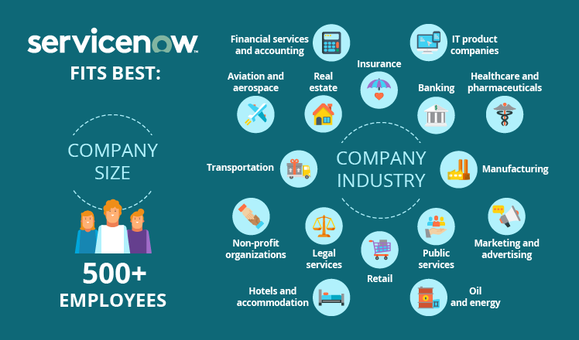

Given the rich ServiceNow functionality and its complex process hierarchy, you should know upfront that the pool of companies that can benefit from the platform is limited to mid-sized and large organizations. [ServiceNow value calculator](https://www.servicenow.com/success/value-calculator-it.html) has 500 as the smallest number of employees in an organization that can gain conceivable savings with the platform’s help. And the reason is simple: if a company is smaller than that, its inner business processes are usually not complicated and tangled enough for complex ServiceNow functionality to optimize them.

As to the industries where ServiceNow can come of use, it can be pretty much anything. Our [ServiceNow implementation specialists](https://www.scnsoft.com/servicenow/services/implementation) do see that some industries tend to use it more often than others, but the application area is still impressive:

|  |  |
| --- | --- |
| * Financial services and accounting * IT product companies * Insurance * Healthcare and pharmaceuticals * Banking * Public services * Retail * Marketing and advertising | * Manufacturing * Oil and energy * Legal services * Hotels and accommodation * Non-profit organizations * Aviation and aerospace * Transportation * Real estate, etc. |

## The results you can achieve with ServiceNow

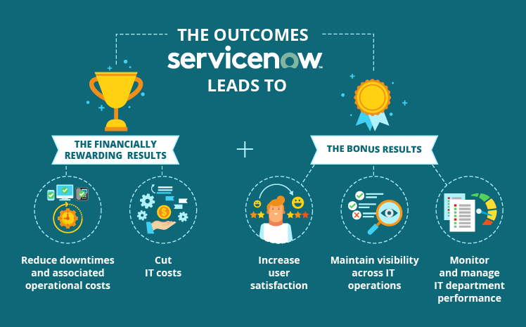

Here are some of the more tangible results that you can achieve with ServiceNow as a ticketing tool for your IT department.

### The financially rewarding results

**Reduce downtimes and associated operational costs**. Long downtimes don’t simply obstruct employee productivity – they cost ugly: if a company has an average of just 5-minute network downtime a month, it loses as much as [$300,000](https://www.itondemand.com/2018/05/29/costs-of-downtime/) on business disruptions a year. Luckily, ServiceNow can curb these losses: for a company of 2,000 employees with 10K yearly tickets (a hundred of which are high priority), ServiceNow [can annually save](https://www.servicenow.com/success/value-calculator-it.html) $208,000 solely by speeding up ticket resolution.

**Cut IT costs**. Continuing the example of the 2,000-employee company, its IT department can save even more due to a productivity increase. They will be able to differentiate ticket types, prioritize them, adequately allocate required resources for their resolution and have IT service provision under control. Additionally, ServiceNow will help them to automate numerous repetitive tasks, such as password resets and access rights requests. According to ServiceNow value calculator, the result means saving not less than $450,000 a year. However, ServiceNow doesn’t exactly show how, so we won’t suggest expecting these figures, at least because it’s the result of implementing more advanced ServiceNow functionality than ticketing.

### The bonus results

**Increase user satisfaction**. Since your average ticket resolution times decreases considerably, you can expect user satisfaction rates to rise proportionally. Well-organized ServiceNow processes may ignite a change in your IT unit’s culture and attitude towards providing support to users, which has to trigger positive user feedback as well. Your users will also find it helpful that ServiceNow keeps them informed about their tickets in a wide variety of ways (from phone calls and emails to web forms) but without bombarding them with emails on every breath the support team takes.

**Maintain visibility across IT operations**. ServiceNow can provide a solid backbone for your IT department’s processes, which will inevitably lead to visibility across IT operations. It will become easier for IT specialists to navigate in a clear and visible process hierarchy and train IT unit newcomers.

**Monitor and manage IT department performance**. To measure the performance of your IT department, ServiceNow provides visual and intuitive reporting functionality. Operational analytics will help your IT service managers to identify service provision problem areas and find ways to improve them. And besides your IT teams, such IT operations reports can be used on a higher administrative level, say, in your enterprise-wide BI solution to assess the performance of the entire organization more comprehensively.

## The technical ABCs of ServiceNow ticketing

Since ServiceNow is considered #1 ITSM platform by none other than [Gartner](https://www.gartner.com/doc/reprints?id=1-5D35O9N&ct=180817&st=sb), we’ll look at the technical specifics of ticketing using IT examples.

### The ticket life cycle

In its classical sense, ServiceNow’s basic equivalent of a ticket is an incident. And to dive into the technical detail of how ServiceNow ticketing works, let’s invent a sample incident of **a broken phone in an office** and look at its life cycle within ServiceNow.

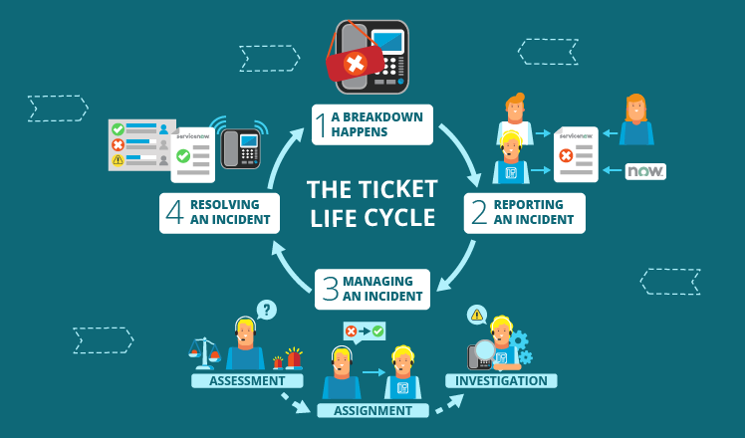

#### Reporting an incident

Employees of different roles can report incidents in different ways:

* An IT staff member can create an incident right in ServiceNow if they spot that some phone doesn’t have a dial tone.
* A userhas more ways to do it: email, a phone call (obviously using another working phone) and a web form on the company’s Service Portal.
* A third-party phone supplier (or a partner) can also participate in reporting incidents if arranged so. For example, if they note the tendency of a certain phone model to lose dial tone, they can report this in the same ways as a user.

Also, ServiceNow can **create incidents automatically**. For example, via regular automated analysis of phone system logs: if ServiceNow finds any malfunctions, it can trigger the creation of an incident.

Here’s how a customer or an employee can report an incident to the IT department through the corporate ServiceNow Service Portal:

#### Managing an incident

ServiceNow works with incidents by following these steps:

1. **Assessment**. When the incident is created in ServiceNow, admins analyze its impact (how badly it can affect the business) and its urgency (how promptly it should be resolved). Based on these two criteria, ServiceNow automatically prioritizes the incident. And this means that SLA-based resolution countdown clock starts ticking.
2. **Assignment**. Using the description of the incident, ServiceNow can automatically assign the incident to an IT specialist that has the relevant expertise to resolve it. Then, the platform notifies the assignee via email. IT employees can, of course, assign incidents manually but automated assignment lets them focus on the more difficult tasks.
3. **Investigation**. The assignee analyses the incident and tries to find a way to restore the undisturbed flow of everyday business processes.

As for the user whose phone stopped working, they can always monitor the incident management process. ServiceNow notifies them of any important support activities. Besides, if the phone starts working again with no IT assistance needed, the user can cancel the incident not to waste IT support time.

Below, you can take a look at the ServiceNow Agent Workspace feature. In this short clip, you will see how an agent gets notified of a newly assigned incident and how conveniently the incident’s details are lined up and loaded into the record from the Service Portal issue opened by a user in the previous video.

#### Resolving an incident

As a solid ticketing system, ServiceNow doesn’t let the tech team hit the ‘Resolve’ button and put the matter to an end. It makes them specify in the incident record a particular type of resolution used (permanently solved, solved through a workaround, not solved, etc.), who resolved it and when.

If the incident is resolved, the associated user needs to close it. In case they don’t, ServiceNow does it automatically within a set period.

If the incident isn’t resolved, escalation rules come into play. As time passes, the system uses measurements of inactivity monitors and, if needed, reminds the support team to take new incident resolution actions. Or, if the incident is close to breaching its related SLA, ServiceNow can escalate its priority. This helps IT teams to stay within allowed resolution times and provide a high-quality service.

In the video below, you can see one more option of how ServiceNow helps agents to stay on top of SLA-related things. Agent Workspace can notify the agent that the time is running out on one of their incidents and enable them to search the Knowledge Base, find the needed incident resolution article, send it to the user in need and resolve the matter.

### The types of tickets and why we need them

Differentiating tickets allows IT departments to work more efficiently. IT specialists need to know what exactly they are dealing with to settle things, which is why ServiceNow has the following types of tickets:

* **Incident** (something that is unplanned and causes interruption to an IT service or reduces its quality).
* **Problem** (a severe malfunction, a cause behind a number of incidents).
* **Request** (something that users want to get from IT support or other involved departments).
* **Change** (a proposal to add, modify or remove something concerning IT services).

The crucial difference between an incident and a problem is that incident management is primarily aimed at restoring the normal flow of business processes as quickly as possible. And problem management aims to find the root cause behind a number of similar incidents to prevent such from happening again. If a ticketing system does not differentiate between these two essential concepts, this may pose a serious threat to IT operations. Ignoring the root cause of similar incidents and coming up with workarounds instead can lead to a substantial decrease in IT services’ efficiency.

### Ticket types shown in a single process

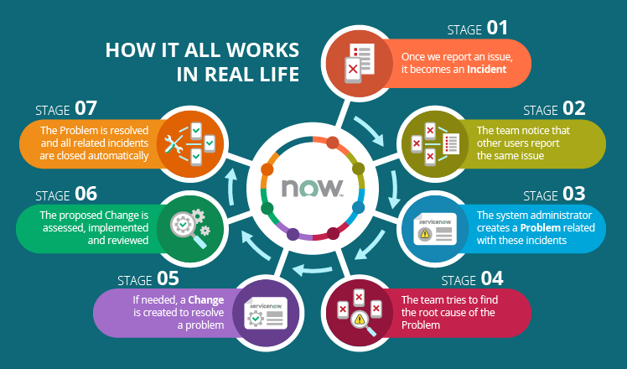

In real life, these ticket types may look like this:

Stage 1: Let’s return to the phone issue. Once it is reported to the tech team, it becomes an **Incident** and gets an assignee.

Stage 2: The assignee goes out of the way to resolve the incident, but then they notice that other users report the same issue with their phones too.

Stage 3: The system administrator notes this tendency and creates a **Problem** in ServiceNow.

Stage 4: Another IT support team member is assigned responsible and tries to find the root cause behind this problem. Let it be an IP phone server malfunction.

Stage 5: If needed, a **Change** is created to resolve a problem. In our case, an IT infrastructure element needs to be changed, so the problem’s assignee proposes a change to choose and install new firmware.

Stage 6: The proposed change is [assessed, implemented and reviewed](https://www.scnsoft.com/blog/itil-change-management-in-servicenow#lifecycle). If the IT specialist responsible for this change plans and carries it out properly, the problem’s root cause will be eliminated.

Stage 7: When the problem is resolved, all related incidents are closed automatically.

Concerning **Requests**, the reason why users contact IT support is different: they seek not a solution but an IT asset. If a user needs, say, a new laptop, email account, software license, etc., they open their company’s Service Portal, select the needed item and wait to get what they need.

In non-IT departments, ServiceNow ticketing can be used to remove process bottlenecks. For example, there are a lot of incidents in the marketing department that concern presentation content delay. One of the managers notes it, investigates the matter and creates a problem saying that the presentation creation process is no longer efficient. As a result, a change is proposed and managers discuss the new way to organize presentation creation. And as soon as they agree on one solution, the change is implemented and the problem is resolved. From now on, presentation content is always ready on time.

## ServiceNow’s soft spots

As ServiceNow projects rarely use the platform’s functionality not configured or customized, the limitations and disadvantages of each ServiceNow solution may be unique. Still, there are some things to keep in mind about ServiceNow:

* **The price is rather high**. Although ServiceNow pricing policy is anything but clear, there is one thing everyone knows for sure – ServiceNow licenses are not cheap. But that’s not all: you also need to be ready to pay for ServiceNow implementation and support. However, if you look at estimated savings, the price will not be an issue.
* **Reporting** ***is not a very strong side***. ServiceNow reporting is more than capable when it comes to low-level operational needs, say, to see how many tickets a particular employee is working on or what priority they are. But if you need some thorough high-level performance dynamics analysis (to see IT unit performance trends and uncover their root causes), you will need to either do it outside of ServiceNow or buy a ServiceNow app called [Performance Analytics](https://www.scnsoft.com/blog/servicenow-performance-analytics-and-reporting).
* **Customizations may require ongoing maintenance**. If your solution is heavily customized, there may be difficulties with making these customizations compatible with future ServiceNow releases. And this will lead to the need for constant customization maintenance. However, if specific development recommendations are respected in the course of ServiceNow customization, you will be able to do with support.

## Possible alternatives

There are numerous alternatives to ServiceNow when it comes to ticketing. To be 100% sure about your ticketing system choice, let’s briefly look at some of them.

##### Small and mid-sized organizations with relatively simple IT processes can try:

* **Spiceworks**

**+**: A free tool that provides ticketing functionality supported with a network scanning feature for keeping track of inventory. There are possibilities to use Service Level Agreements (SLAs) and reporting and build a branded user portal.